POLO FIELD HIRE 2016
Kurri Burri Polo Club is opening its gates and offering public hire of its Number 1. polo field.
Kurri Burri Number 1. is managed by our in house agronomist who is also the chief adviser for the ANZ Stadium sports ground. He works closely with the maintenance team at Kurri Burri to ensure our ground is maintained to the higest standard. It is sanded and de thatched twice a year and hosts professional sports field drainage to enable a safe playing surface in wet weather conditions.
Kurri Burri has an unriveled reputation for being one of the best high goal grounds in the area.
Kurri Burri Number 1.
- Full size playing surface
- Curved boards
- Sports field drainage
- Digital remote score board
- Fresh line marking
- Padded full size goal posts
- Ample truck parking
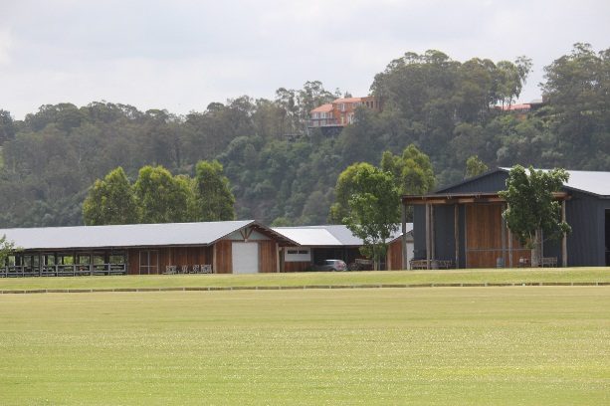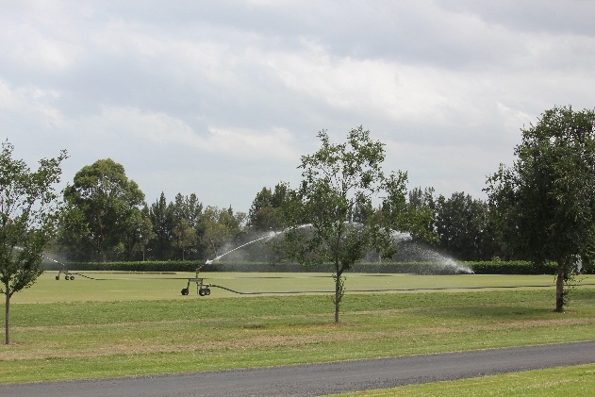
For further information or to arrange an inspection please contact General Manager, Hugh Bloore
Ph: +61 414 255 518
Email: hughb@marshall.com.au

