Thank you to our Sponsors

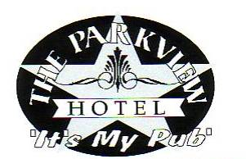

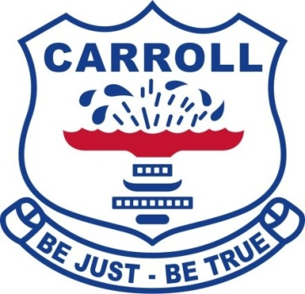

Thankyou to AMPS &Pursehouse Rural for the
use of their tents & cool room

All goal umpires must be registered Players
and must wear helmets.

All dogs must be on leads

Gunnedah Polo Club
Saturday 24th & Sunday 25th August 2019

Patron: Mr George Witts
President: Mark Barber
Secretary: Renata Davidson
Treasurer: Ben Osborne
Club Captain: Phil Clift

Trophies to be Played for

Gunnedah Cup (A Grade)
The Kibah Cup (Beaten A Grade)
CH Edwards Cup (B Grade)
The W.J. Maslin Memorial Trophy (Beaten B Grade)

A Grade Pony – Donated by the Maslin Family
B Grade Pony – Donated by Mrs M Clift
The Douglas Baker Trophy for Team of Ponies
Donated by the Baker family
The Club Pony – Donated by the Witts Family
Pony Played by a 0 Goaler or less
Donated by the Alker Family
The Don Clift Trophy for Best & Fairest Player
Donated by Clift family
B&H Mazoudier Memorial for Best & Fairest Junior in the Junior Competition
Donated by L Mazoudier
Most Improved Gunnedah Player
Donated by the Parkview Hotel

Saturday

B Grade (4 Chukkas)

Match 1 – 10.30 am

Gunedah B vs Wirragula B
1. Jack Davidson -2 1. Duncan Dew -2
2. James Hockey 1 2. Annabel Wilson -2
3. Mark Barber 1 3. Jock Macay 4
4. Colin Campbell -1 4. Andre Parrot 1
-1 1
Umpires: Paul McGinley & Ben Osborne
Goal Umpires: Rob Davies & Al Simson

Match 2 – 11.30 am

Gunnedah A vs Tamarang B
1 Sam Osborne -2 1. Sam Thompson -2
2. Ben Osborne 1 2. Andrew Campbell -1
3. Earl Herbert 2 3. Bryce McMurtrie 1
4. Gerard O’Leary 0 4. Will Simson 1
1 -1

Umpires: Scott McCreery & Doug Munro
Goal Umpires: Scott Chambers & Haydn O’Leary

Junior Match – 12.30pm (1 Chukka)

A Grade (4 Chukkas)

Match 3 – 1 pm

Carmyle vs Wirragula A
1 Al Simson 0 1. Cameron Wilson -1
2. Paul McGinley 1 2. Treen Murphy 0
3. Will Simson 1 3. Rob Davies 1
4. Andre Parrott 1 4. Jock Mackay -1
3 4

Umpires: Earl Herbert & Angus Scott
Goal Umpires: Duncan Dew & Jack Davidson
Match 4 – 2 pm

Tamarang A vs Quirindi
1 Scott Chambers 0 1. Haydn O’Leary -2
2. Bryce McMurtrie 1 2. Scott McCreery 1 3. Angus Scott 2 3. Doug Munro 2
4. Mark Barber 1 4. James Hockey 1
4 4

Umpires: Jock Mackay & Wil Simson
Goal Umpires: Andrew Campbell & Sam Osborne

Sunday

Match 5 – 10.30 am
The W.J Maslin Memorial Trophy

Beaten B Grade from Matches 1 & 2

Goal Umpires – Teams from Match 7

Winners ..............................................................

Match 6 – 11.30 am

Kibah Cup

Beaten A Grade from Matches 3 & 4

Goal Umpires – Teams from Match 8

Winners ..............................................................

Junior Match – 12.30pm

Winners ..............................................................

Match 7 – 1pm
CH Edwards Cup

B Grade Final Winners of Matches 1 & 2

Goal Umpires –Teams from Match 5

Winners ..............................................................

Match 8 – 2pm

Gunnedah Cup

A Grade Final Winners of Matches 3 & 4

Goal Umpires –Teams from Match 6

Winners ..............................................................

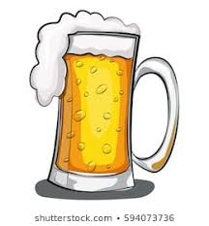

Join us at the Parkview Hotel Saturday night for dinner and drinks!

